Shrinking Civic Spaces in Institutions of Higher Learning Project
Psychosocial Support and Building Resilience among University Students

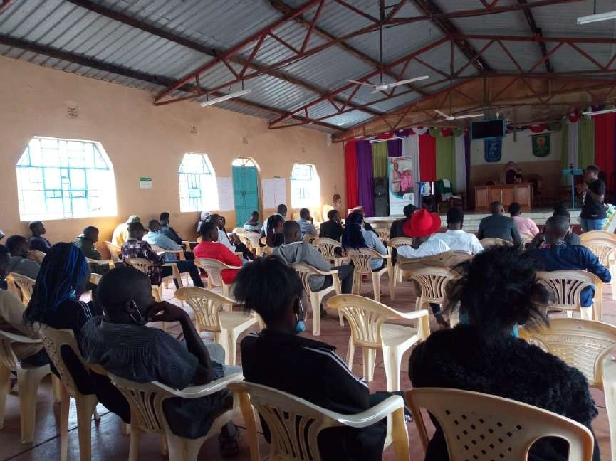

14 November 2020 | Anglican Church of Kenya, Kenyatta University Market, Nairobi

Compiled by Leonida Odongo

Disclaimer

The content of this publication is the sole responsibility of Haki Nawiri Afrika and does not necessarily reflect a position of RLS

Table of Contents
Background 3
Introduction 3
Expectations 4
Fears among University Students 5
Addressing Fears 6
Relationships 7
Choice of friends 8
Personality 8
Self analysis 8
Fear of cockroaches 9
Attachments and fear of losing friendships 9
Participants’ Comments 9
Session Evaluation and Wrap up 10
Conclusion 11
References 12

Background

The psychosocial dialogue was a component handling of issues affecting students in institutions of higher learning and creating safe spaces where students can share what is affecting them and at the same time explore solutions to the issues raised.

Introduction
The dialogue had 54 participants (39 males: 15 females). The represented institutions were University of Nairobi, Haki Nawiri Afrika and Kenyatta University. The dialogue was held at the Anglican Church of Kenya –Kiwanja .The objectives of the dialogue were:

- To share experiences on issues affecting young people
- Discuss fears that students have and how to address the fears
- Identify referral mechanisms capable of addressing the identified issues

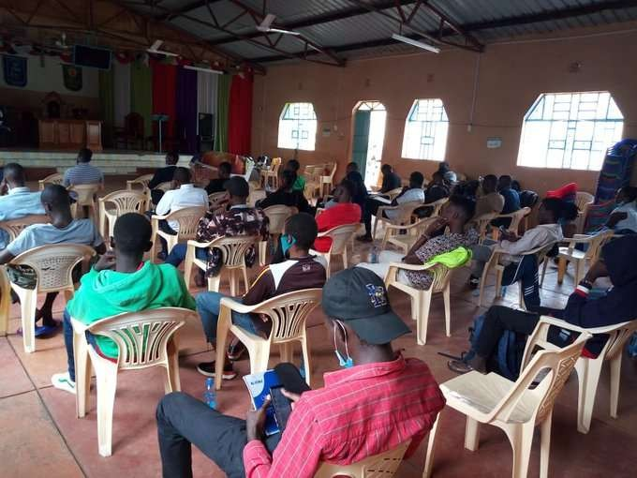
Cross section of participants

Expectations

The participants stated their expectations as follows:
- To learn how to cope with life
- To understand how to accept situations
- To be better at decision making
- To learn from one another

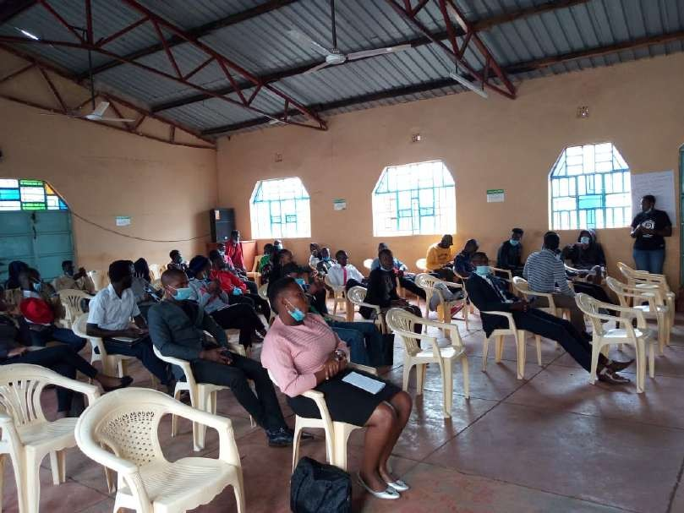
Sharing Expectations of the Psychosocial and Resilience Building dialogue

Fears among University Students

Asked what their fears were, the participants shared the following:
- Living a life of poverty
- Suffering/poverty
- What the future holds
- Graduating and not getting a job
- Fear of death
- Not achieving one’s dreams
- Fear of falling in love
- Experience of hunger (not having adequate food)
- Financial insecurity (being auctioned)
- Fear of losing people (people they love)
- Fear of creepy animals (cockroaches)
- Marrying the wrong person
- Fear of being judged
- Unforeseen events
- Death
- Challenge of self identity
- Living with a wrong soul-mate
- Fear of failure

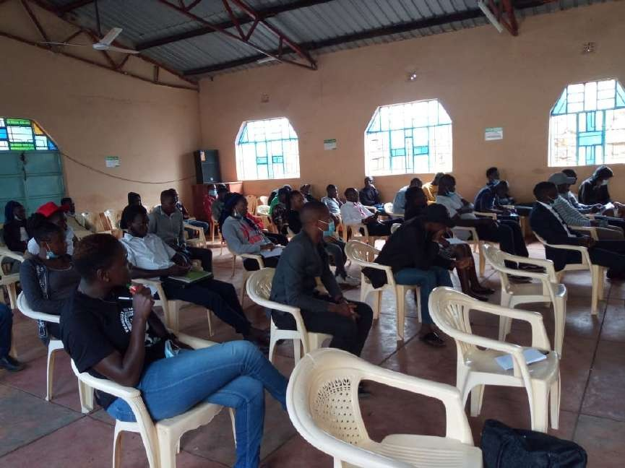
Experience sharing on Fears

Addressing Fears

In addressing the fears, the participants were taken through various strategies they can use to cope as follows:

It was mentioned that fear is a mental enemy and has to be conquered. It was said that it is natural to have fear but it becomes problematic when one allows fear to control their lives. It was mentioned that fear bring unhappiness and interferes with moods. It was also pointed out that fear does not accomplish anything and that it saps the body of energy.

It was explained that the best way to overcome fear is to analyse it, understand the cause and address the root cause .It was said that sometimes the cause of fear is something one can control but at other times it is something one cannot control. It was noted that fear of things that happened in the past is something one cannot do anything about but has a responsibility of working towards making this fear not interfere with their current moods or happiness. It was mentioned that it is important to master one’s tensions and learn how to relax.

It was said that for those who fear to fail, failure is something every human being encounters from time to time and that when one fails, they should not look at it as final but keep on trying .It was elaborated that to overcame fear of failure, one needs to look at the failure as a learning experience. It was emphasised that patience is important and that being focused also helps one address fears. Persistence was further cited as a key element in dealing with the fear of failure
.It was said that everybody has a story and started from somewhere.

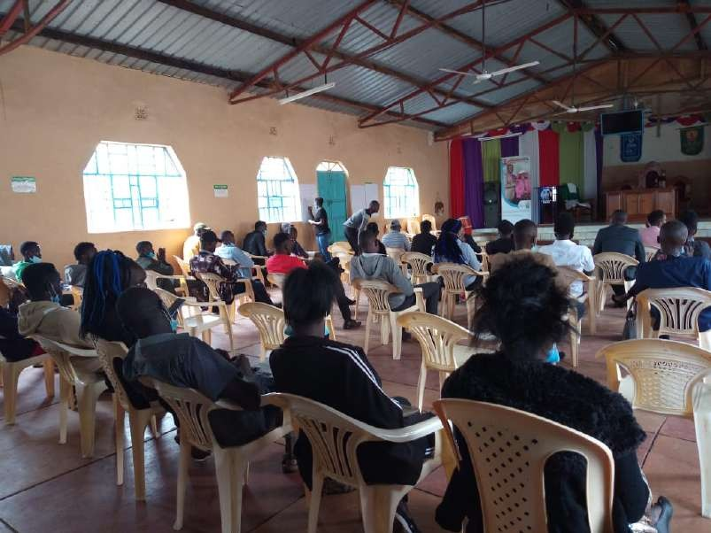
Deliberation on issues affecting students

Relationships

It was said that one of the greatest sources of stress among university students is broken relationships and this affects their performance in exams. It was also mentioned that of many young people who have affairs with older men, the reason is economic as well as search for a father figure. It was discussed that the attention we get in our families growing up has an impact in the way we cope as adults.

The participants were cautioned not give their entire heart to a relationship, know what brought them to the university and focus. It was stated that it is important to know what one wants in a relationship .It was also mentioned that students should not rush into relationships but take their time to get to know each other to prevent enduring heartbreaks. It was said that different people get into relationships for different reasons, for some it is for love, others for lust and others to revenge. The participants were cautioned against revenge in relationships in that it ends hurting many people.

Attachment in Relationships

Existing attachment styles in relationships were described as follows:
Secure | Anxious
Characteristics | Characteristics
- Can trust fairly easily  - Has flexible behaviour in relationships  - Can communicate directly when upset  - Capable of handling emotions | - Has a sensitive nervous system  - Struggles to communicate needs directly  - Tends to “ act out” when triggered (makes the partner  jealous)
Avoidance -Dismissive | Avoidance-Fearful
Characteristics | Characteristics
- Downplays the importance of relationships  - Is usually extremely self reliant  - Capable of becoming more vulnerable with a big crisis | - Avoidant-Fearful  - More dependent in relationships than avoidant- dismissive  - Has a low self-esteem  - Has a high anxiety in relationships  - Strongly fears rejection

Experience sharing on relationships
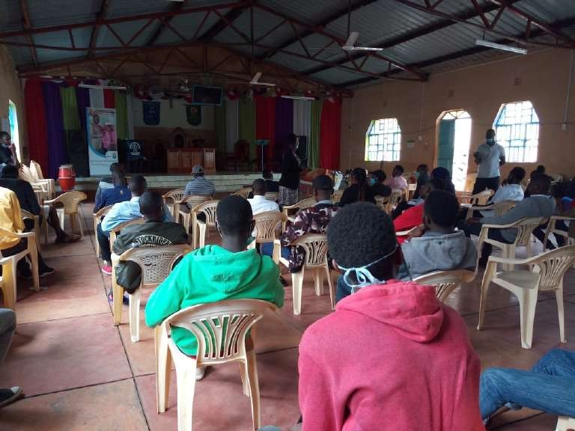

Choice of friends
It was mentioned that one should be careful the type of friends they choose and should make the right choices .It was mentioned that friends have an influence on a person’s behaviour hence the importance of being keen while choosing friends.

Personality
It was said that different people have different personalities and their personalities is a determinant of how they behave and how they cope. Sensitivity was emphasised in handling other people as well as when talking to people. Each student was asked to go online and get to understand their personality, identifying weaknesses and how to address these weaknesses.

Self-analysis
The participants were each asked to take time to do a thorough self-analysis. Understand and be able to respond to the question who am I. It was said that self-acceptance is the beginning of healing and is the beginning of addressing stress. It was emphasised that we have to accept ourselves the way we are and this is important for contentment.

Exploring Solutions to Issues affecting university students
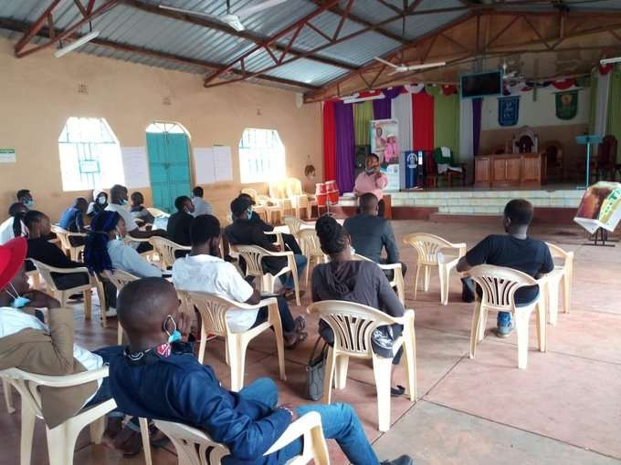

Fear of cockroaches
This was said could be addressed by cleanliness and sanitation. Cleanliness was emphasised as an important aspect of good health.

Attachments and fear of losing friendships
It was discussed that the majority of conflict related cases among university students have to do with relationships .It was said that male and female students get into relationships for different reasons. Some for company, others for love while others for lust. It was said that one’s background and upbringing has an impact in how one navigates relationships.

Participants’ Comments

The participants had the following comments and observations
- Young people have to do the best with their lives
- It is okay to have fears because we are all human beings
- Student leaders have a lot of pressure especially handling cases where fellow students lack basic necessities such as food
- Youth unemployment is a cross cutting fear among students

- Dysfunctional families have an impact on how university students and young people in general cope and this also affects their interpersonal relationships
- It is important to engage people who have ideas and to learn from them
- Students need to know that they are in university for just bus a short time and have to make the best of the opportunity
- A lot of opportunities exist but students need to be keen, network and connect to access these opportunities
- Students to take advantage of the online trainings and meetings, these are avenues for exposure as well as networking which will benefit them in future
- On mental health, it was said that is it the individual student who holds the key to their own happiness
- Self acceptance is very important, when you accept yourself your self image improves
- Young people should strive to have own identity and not live in the shadows of others
- It is important to be sensitive on what we tell others because people take in things differently and some people are unable to cope

Session Evaluation and Wrap up
- The participants appreciated the session and commented that they felt safe to discuss issues affecting them
- It was mentioned that the participants felt listened to and some of their fears had been addressed through participating in the dialogue. It was noted that some of the participants had difficulties navigating issues of relationships and this was compounded by freedom available in universities .It was said that some students lack basic necessities, the main being lack of food. It was pointed out that there is need to create a brother’s keeper model where students reach out to fellow students in case of problems. It was mentioned that there is need for further management in case of students who abuse drugs .It was stated that emerging cases from the dialogues would be referred to the Counselling department at Kenyatta university through connecting with peer counsellors and making referrals to professionals outside the university setting.

Conclusion
The dialogue achieved set objectives of creating a safe space for students to discuss issues affecting them and at the same time explore solutions. The platform further provided the participants with an assurance that solutions to issues affecting them were available. The dialogue also emphasised the importance of referrals in addressing issues affecting students.

Evaluating the Psychosocial Support and Resilience Building Dialogue
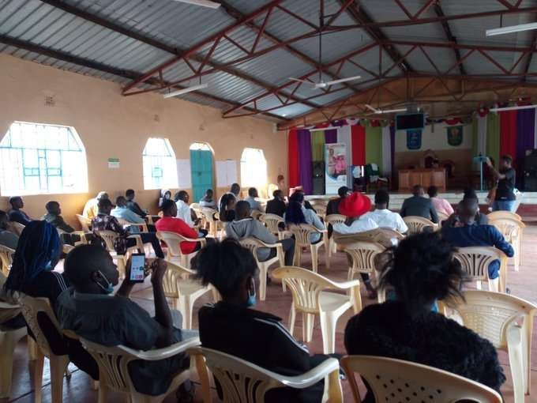

It was be concluded that the dialogue provided the students with space for experience sharing on their day to day struggles and a platform to explore ways of resolving challenges they go through. The students also reported gaining an alternative perspective of looking at life .It was also shared that it would be beneficial to have more of similar interactions and bring on board various experts to share their expertise with the students.

Sponsored by the Rosa Luxemburg Stiftung with funds of the Federal Ministry for Economic Cooperation and Development of the Federal Republic of Germany. This publication or parts of it can be used by others for free as long as they provide a proper reference to the original publication.

References
https://psychologytoday.tests.psychtests.com/bin/transfer

